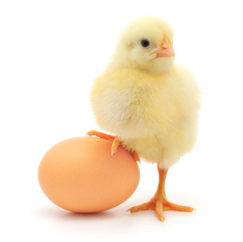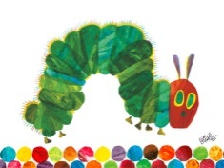

**Literacy:**

The Very Hungry Caterpillar. Writing sentences with punctuation..

Continuing to write their own name with correct letter formation.

Letters and sounds phase 3 focusing on blending and segmenting.

**Expressive arts and design:**

Creating art work of own choice related to living things.

In music, children will be creating their own music using a range of instruments.

**Personal, social and emotional development:**

‘Changes’ activities.

Talking about setting achievable targets for themselves.

Turn taking games and circle time.

Reception topic web

Summer 1

‘How do living things change?’

**Understanding the world:**

Finding out about different lifecycles of animals – caterpillar, chicken and tadpoles.

Planting seeds and learning about what they need to be able to grow.

Talking about special times with our families & the ways we celebrate things.

ICT – Using ICT to find out information.

**Physical development:**

Health and self-care – continue to practise managing own needs including dressing and undressing independently, personal hygiene and understanding the need to keep healthy (& know ways to do so) and looking at the effects of exercise on the body.

Movement – we will explore different ways of moving, moving to music and using movement to retell stories.

**Mathematics: -**Continuing counting and ordering numbers to 20. Counting a set number of objects.

1 more and 1 less.

Addition & subtraction using objects and number facts.

Using everyday language related to time.

Money – recognising coins and using everyday language related to money.

**Communication and language:**

Focusing on asking and answering ‘how’ and ‘why’ questions by doing activities such as freeze framing and hot seating during literacy.