Forest School Fridays!
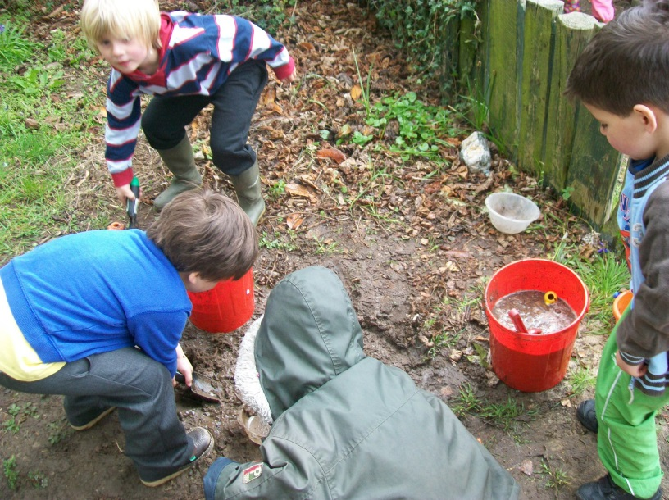

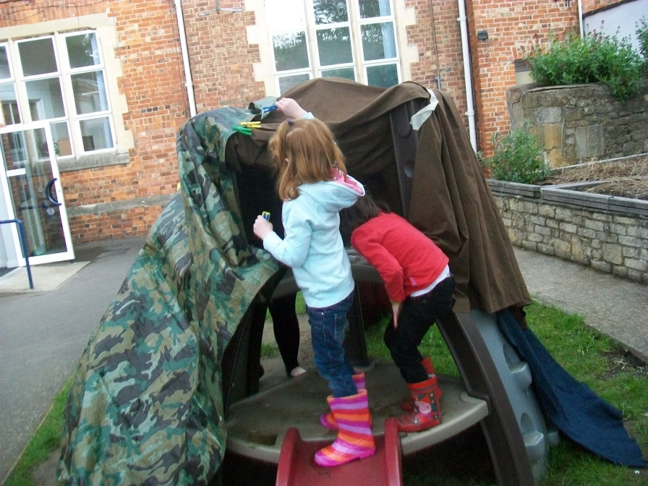

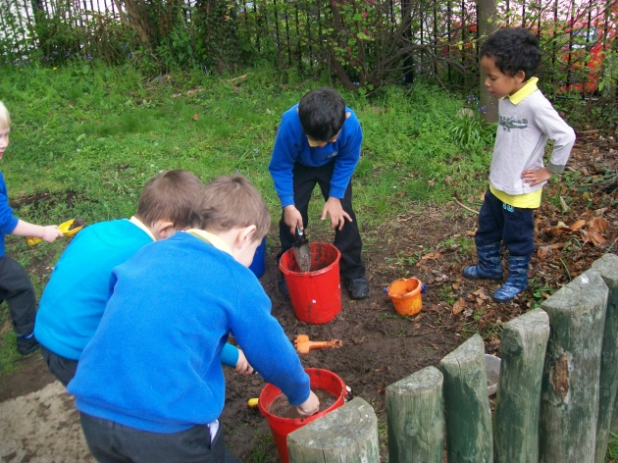
Every week we have now started ‘Forest School Fridays’ where we have a roundabout of activities. This Messy play involves:
- children using all their senses in the process of exploration, especially the sense of touch.
- offering children plenty of opportunity to mould and manipulate materials
- not having a focus on making or producing something, leaving the child free to explore all sorts of possibilities. It taps into children's innate curiosity about the world around them and their desire to explore and find out more.

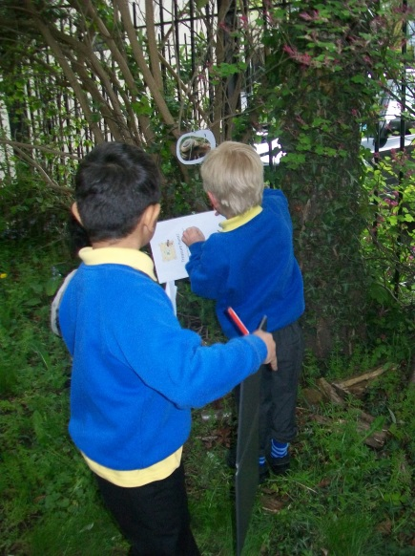
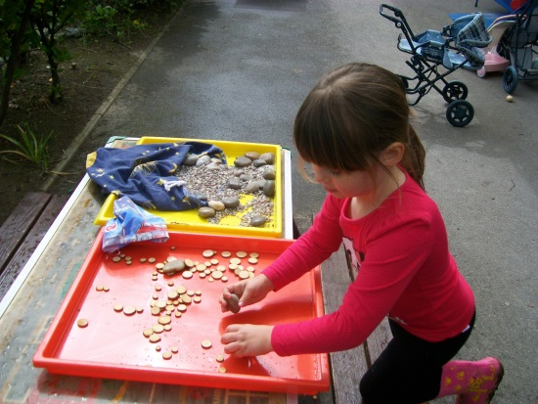
However, messy play offers children many opportunities for learning:

Personal, social and emotional development
(Includes self-confidence and self-esteem, social development including making relationships and emotional development including self-control.)
Messy play builds on children's curiosity and encourages a positive approach to new experiences. Children display a high level of involvement and can select and use resources independently. In messy play, children can develop concentration, problem-solving, planning and seeing things through to completion. Working with others fosters self-respect, and respect for others. It helps children to share, interact and observe others and to understand that there needs to be agreed values and codes of behaviour for groups to work together harmoniously. Messy play also offers children opportunities to represent experiences, feelings and thoughts.
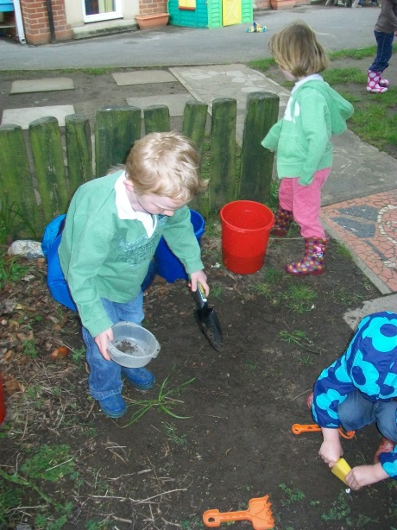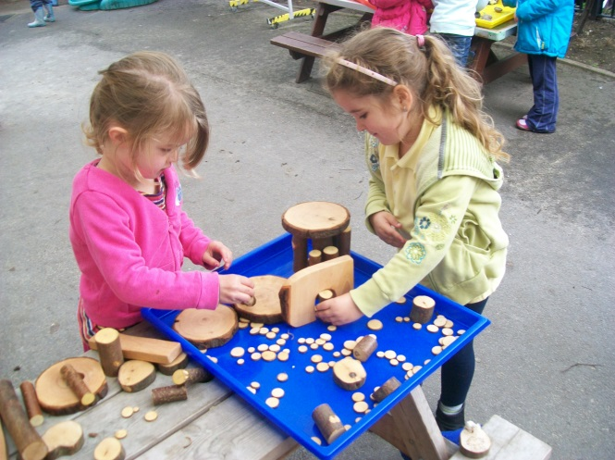

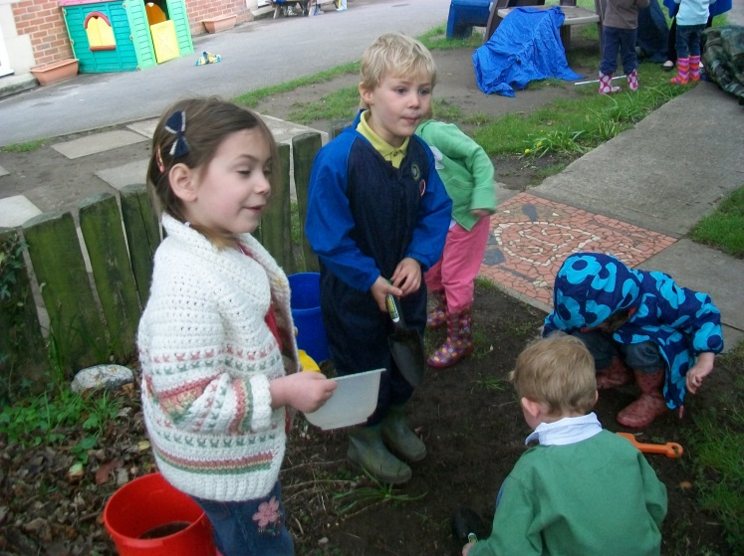

Communication and language.
Literacy
(Includes language for communicating and listening, reading and writing.)
Messy play offers opportunities for children to speak and listen, for example, when sharing resources. Children use words and/or gestures to communicate and the informal context encourages confidence. Such play provides meaningful opportunities for children to talk through activities, reflect and modify actions, negotiate plans and activities and to take turns in conversation. The children are beginning to understand making marks with materials and ascribing meanings to them leads to understanding the symbolic nature of written language. Messy play develops the fine motor skills needed for writing, for example, hand-eye coordination and narrative skills necessary for storytelling are developed as children start to tell stories using materials.
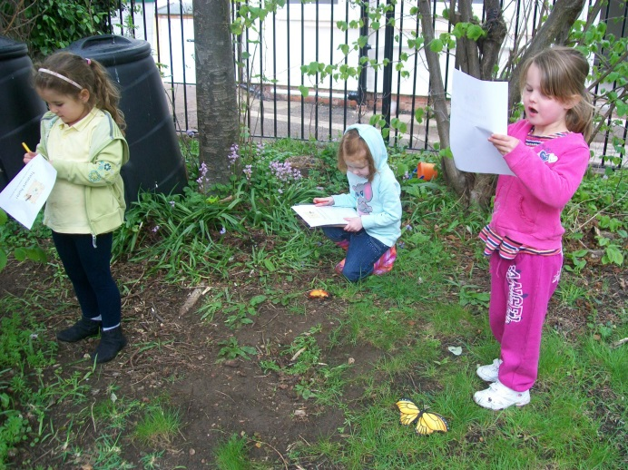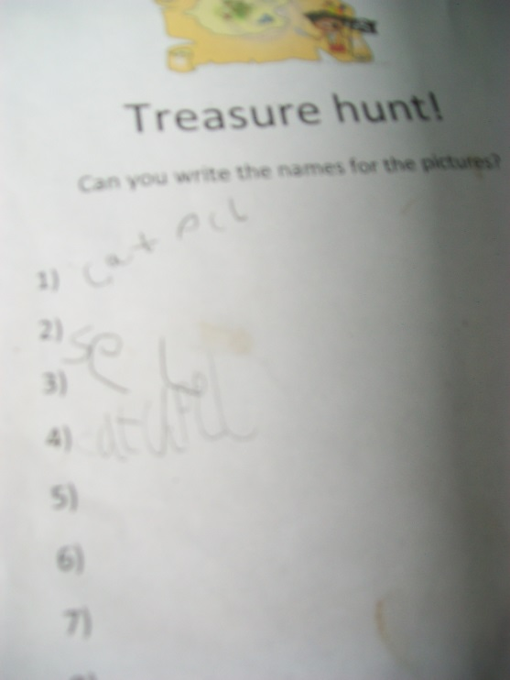

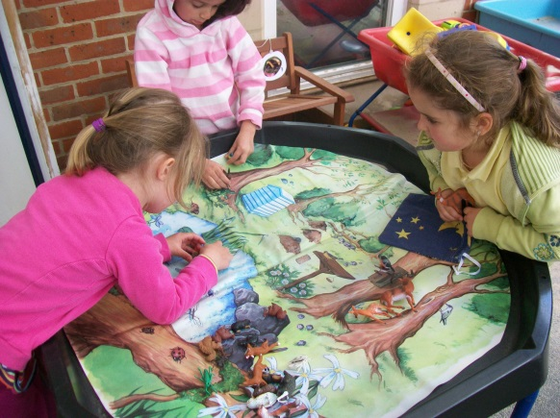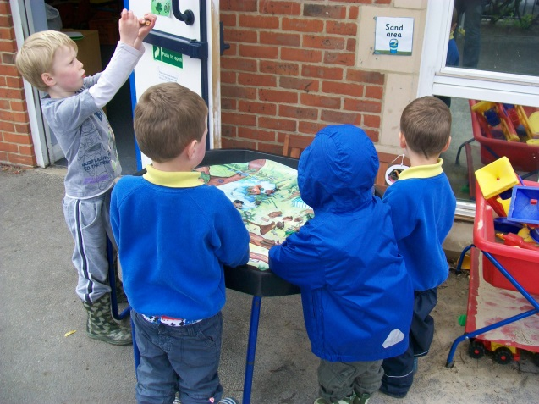

Physical development
(Includes movement and using equipment, tools and materials.)
Children can develop and practise fine motor control and co-ordination through using and handling tools, objects and malleable materials safely and in a meaningful context. They are also developing body control, poise, balance, co-ordination and control in large and small movements through messy play on a large scale, such as transporting water and sand around
the garden.

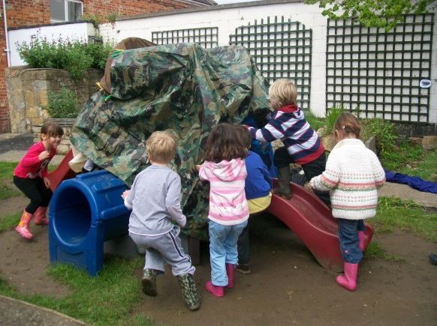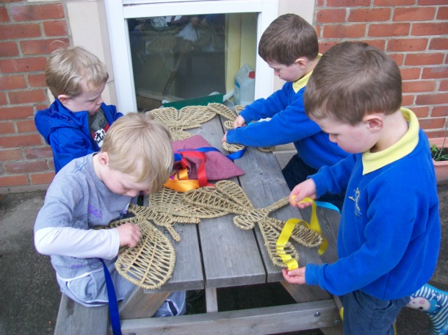

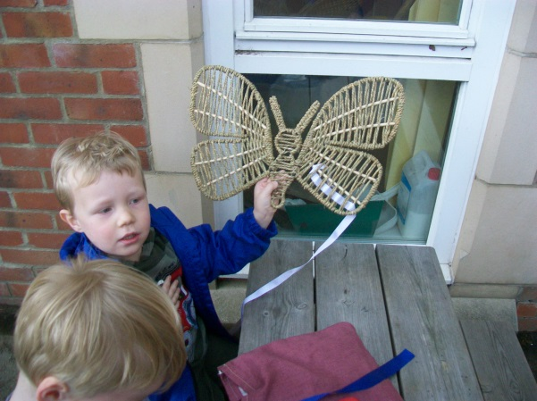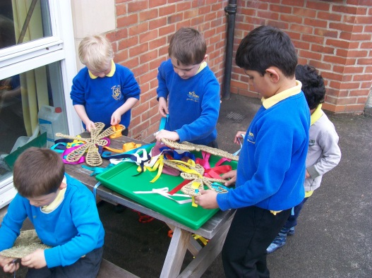

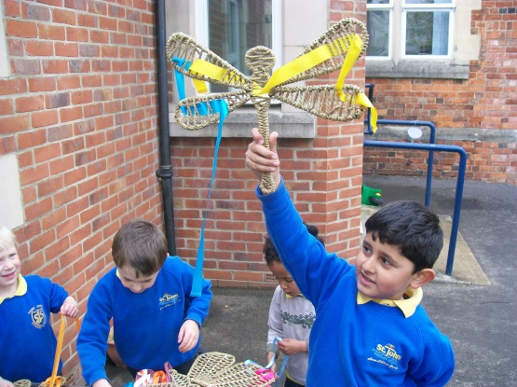

Mathematics
(Includes counting, calculating shape, space and measure.)
Messy play offers meaningful opportunities for counting. For example, in sharing out resources
and responding to questions such as, 'Who has more/ fewer?' Children learn about concepts of shape, size, line and area as they sort objects and develop
their interest in shape and space by playing with shapes or making arrangements with objects.
They can explore spatial concepts and use everyday words to describe position. Sequencing events and objects, for example, when creating a pattern on a piece of clay, help children to understand patterns. Children use language such as heavier or lighter to compare quantities and methods to solve practical problems.

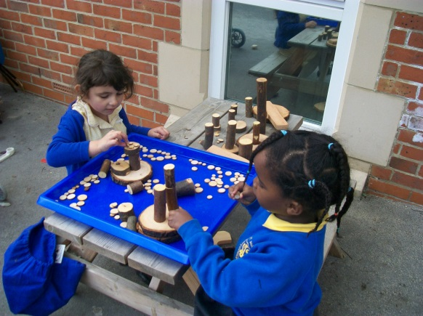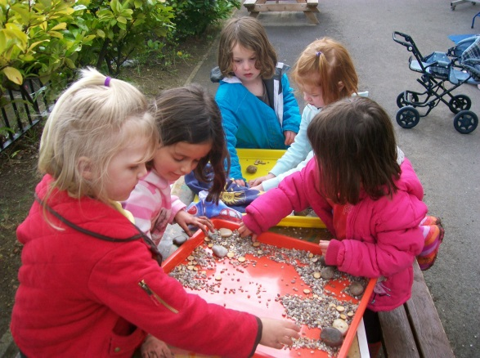

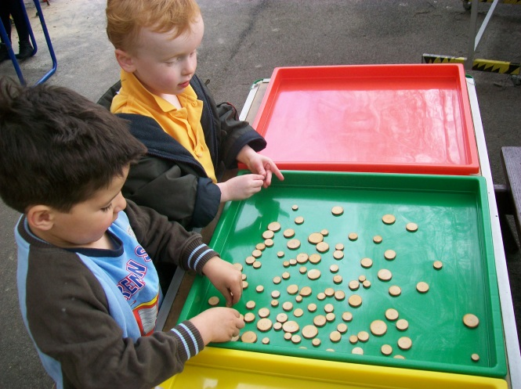

Understanding of the world
(Includes exploration, investigation, designing and making skills.)
Messy play fosters children's interest in the world in which they live and offers them opportunities to investigate when presented with unfamiliar resources with differing properties.
Children can observe, select and manipulate objects and materials and identify simple features, similarities and differences, using all of the senses as appropriate. Messy play encourages children to set their own challenges, to problem solve and find out about cause
and effect.
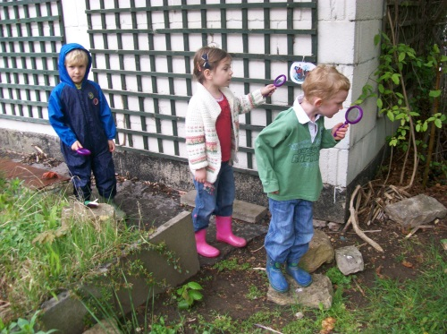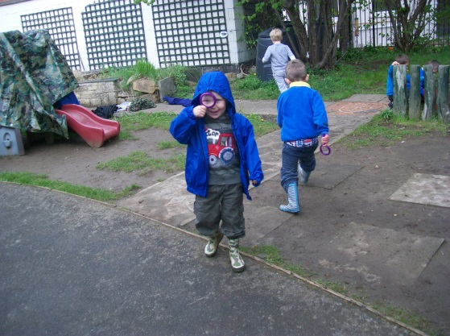

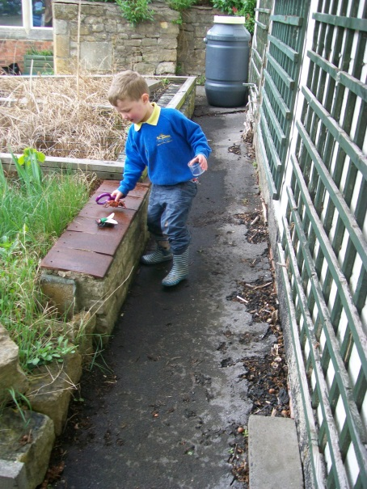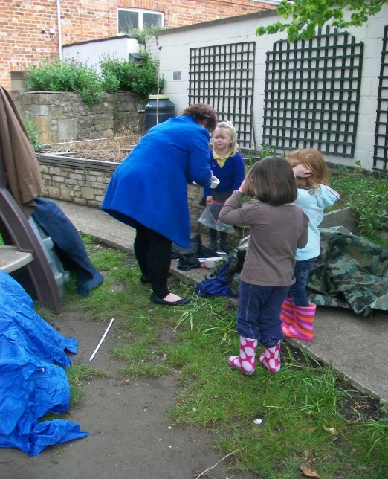

Expressive Art and Design

(Includes exploring media and materials, imagination and responding to experiences.)
Messy play fosters children's interest in and allows them to respond to what they see, hear, smell, touch and feel. They notice what adults do and can imitate what is observed. They can explore and respond to different media and sensory experiences. As materials become familiar, they use them in representational play. They express and communicate ideas, thoughts and feelings and explore colour, texture, shape, form and space in two or three dimensions.

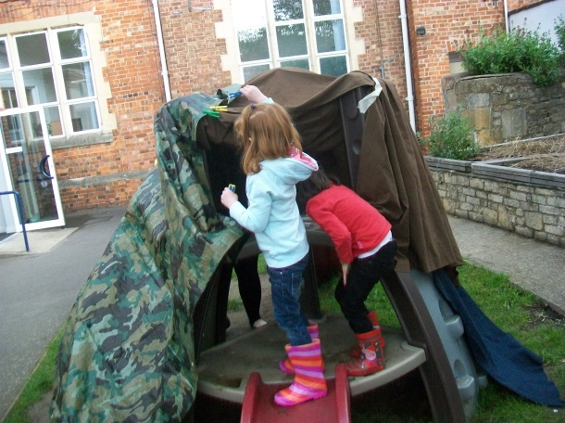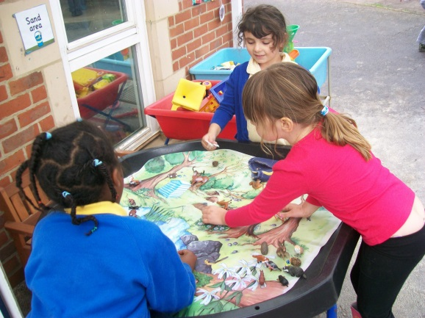

Further activities to be developed are:
- working with drainpipes
- ‘painting’ on a large scale
- Building a home for ‘toy’ animals
- Environment sounds bingo
- Liaison with Holy Trinity Forest area
- Trip to Forest of Dean

This week it had been torrential rain all week so we were able to incorporate the puddles into our ‘merry go round’ of activities. There was an amazing puddle in the bottom of the junior playground.

