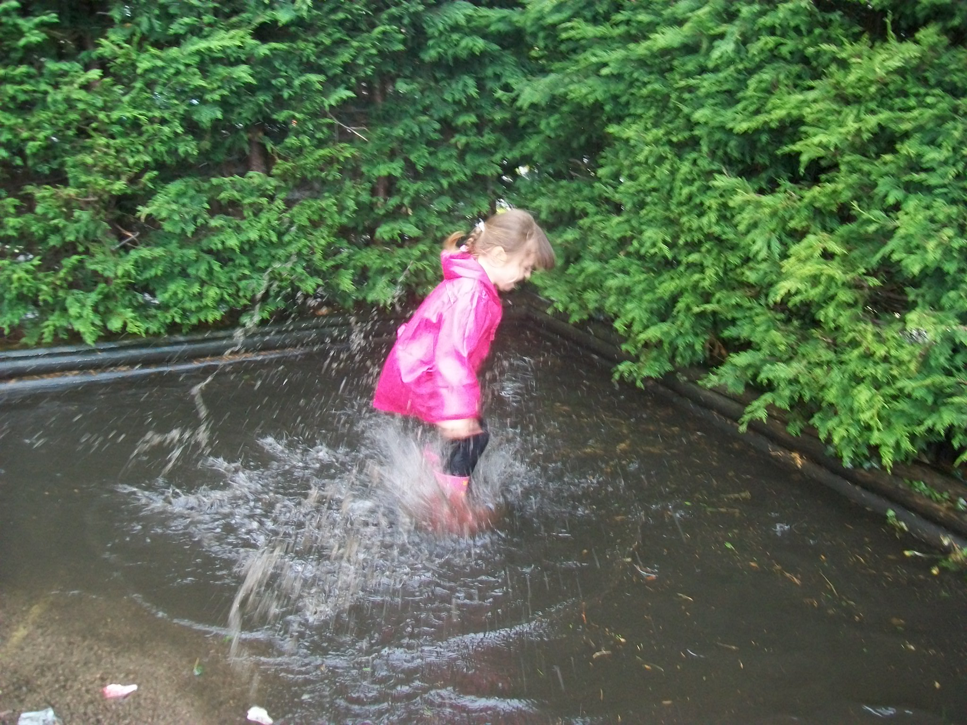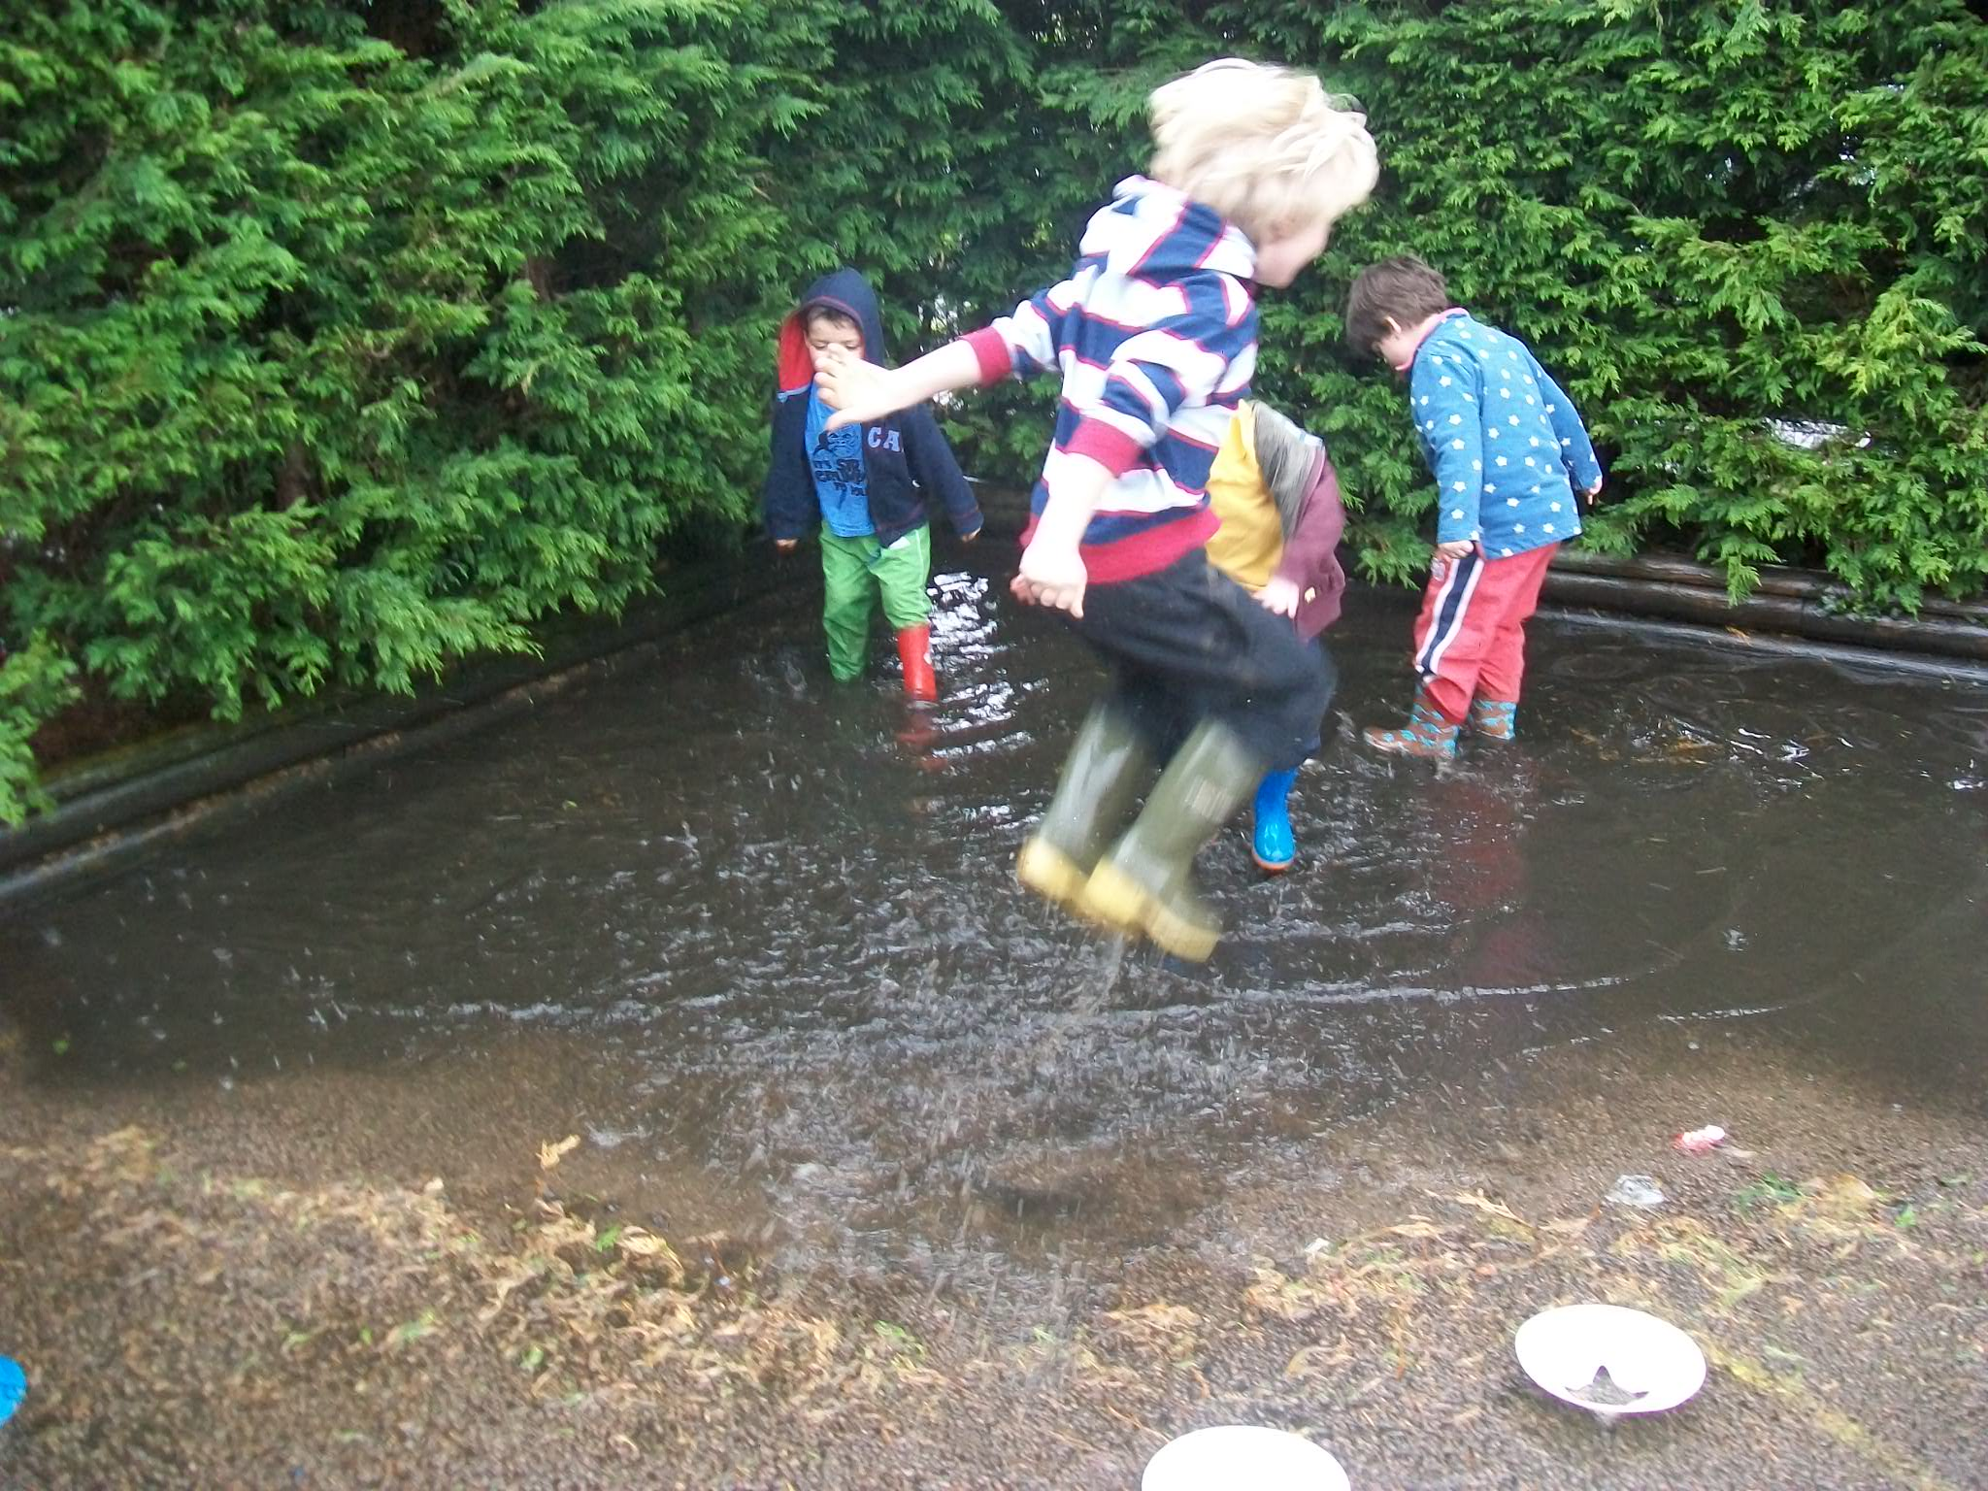
Forest School Fridays!

Every Friday the Reception Class take part in ‘Forest School’ messy activities to develop their exploration, investigation, manipulation and co-operation skills. These activities promote the Early years curriculum, as well as being fun, and include making channels for drainpipes, den building and making mud pies plus many more!

Please can you send your child dressed in ‘messy’ clothes (jeans/leggings, wellingtons, waterproof coat etc) EVERY FRIDAY MORNING and bring SCHOOL UNIFORM in a bag to change into.

Many thanks.



