Year 2 Home Learning Ideas
Lots of English resources

https://www.bbc.co.uk/bitesize/topics/zd63xyc/articles/zncgvk7
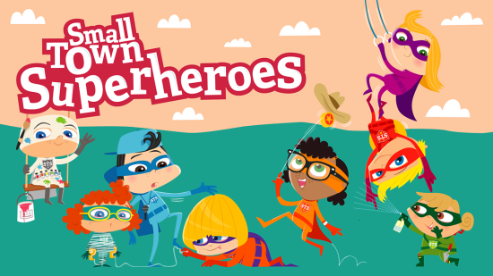 | Play Small Town Superheroes | KS1 Literacy | English | Free Online Game for Kids - BBC Bitesize  Practice your KS1 English skills alongside the Small Town Superheroes! Use your reading, writing, spelling, grammar and punctuation skills to help the heroes complete their missions. Suitable for ...  www.bbc.co.uk
https://www.bbc.co.uk/teach/supermovers/ks1-collection/zbr4scw

Maths, English, even PSHE!

https://www.bbc.co.uk/bitesize/topics/zd63xyc/articles/zdp4pg8
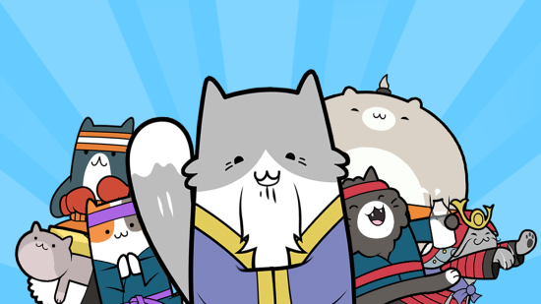 | Play Karate Cats Game For Kids | Free Online Spelling Games - BBC Bitesize  Improve your grammar, punctuation and spelling with the Karate Cats! Prepare for the Year 2 English SATs test. Suitable for primary school KS1 children and featuring the voice of David Tennant  www.bbc.co.uk
https://www.bbc.co.uk/bitesize/subjects/z6svr82
KS1 Science - BBC Bitesize
KS1 Science learning resources for adults, children, parents and teachers organised by topic.
www.bbc.co.uk

https://www.topmarks.co.uk/maths-games/mental-maths-train
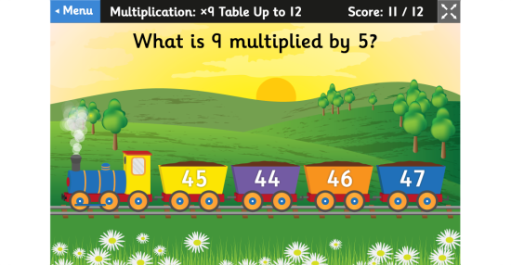 | Mental Maths Train - A Four Operations Game  Mental Maths Train is a maths game which focuses on the vital vocabulary of addition, subtraction, multiplication and division. It helps children understand what type of calculation they have to do when faced with word problems.  www.topmarks.co.uk
https://www.gonoodle.com/
Home - GoNoodle
GoNoodle® engages 14 million kids every month with movement and mindfulness videos created by child development experts. Available for free at school, home, and everywhere kids are!
www.gonoodle.com
https://www.oxfordowl.co.uk/for-home/find-a-book/library-page/
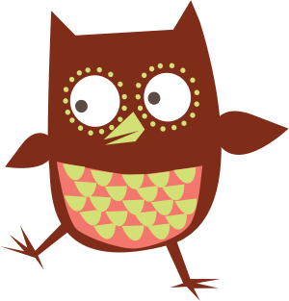 | Free eBook library | Oxford Owl from Oxford University Press  FREE eBook Library. Welcome to our free eBooks collection, developed for children aged 3–11 years old. Help your young child learn to read, and love to read, with our range of over 100 free eBooks.  www.oxfordowl.co.uk
https://spellingframe.co.uk/

SpellingFrame
Choose a spelling rule then choose to either practise the spelling or take a test with those words. All words are read aloud (make sure your sound is turned up) and provided within a sentence for context.
spellingframe.co.uk
https://www.bbc.co.uk/teach/ks1-history/z6h3jhv
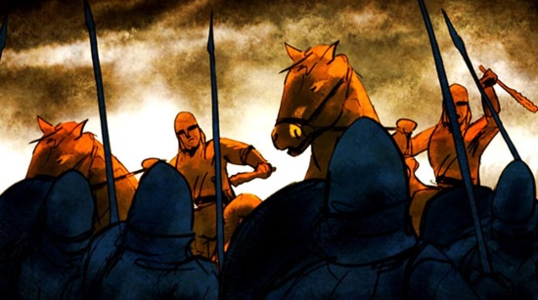 | KS1 History - BBC Teach  Free teacher classroom resources suitable for use in history lessons with primary school children at Key Stage 1 in England, Wales and Northern Ireland, and at 1st Level in Scotland. This series ...  www.bbc.co.uk
https://www.bbc.co.uk/bitesize/subjects/zcdqxnb

KS1 Geography - BBC Bitesize
KS1 Geography learning resources for adults, children, parents and teachers organised by topic.
www.bbc.co.uk
https://www.bbc.co.uk/teach/ks1-physical-education/zdqhcqt
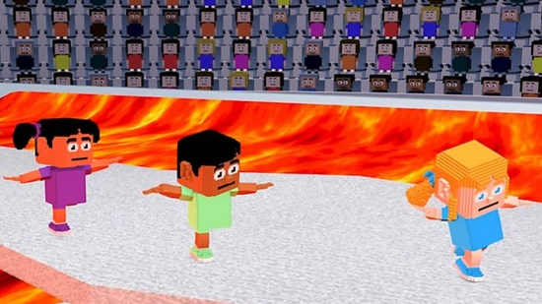 | KS1 Physical Education - BBC Teach  Free teacher classroom resources suitable for use in Physical Education lessons with primary school children at Key Stage 1 in England, Wales and Northern Ireland, and at 1st Level in Scotland.  www.bbc.co.uk

